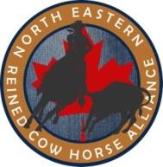

WAIVER AND CONSENT
(FOR 14 – 18 YEAR OLDS ONLY)

I ____________________________________ at the age of _____ years old have chosen to ride my horse in the show pen at ________________________________________________________ without wearing an approved safety helmet.
As the parent of _________________________________________, I hereby give consent for my child to ride his/her horse in the show pen at ______________________________________________________ without wearing an approved safety helmet.
We understand and acknowledge the risk of serious injury and possible death that could arise from failure to wear a helmet, and I release the Northeastern Reined Cow Horse Alliance, its Executive, and the owners and managers of this show facility from any and all liability relating to such potential injury and/or death.

______________________ __________________________ _________
Name Signature Date

______________________ __________________________ _________
Name Signature Date

